
CV of Accountant (Janab Molla Sabir)
Proposed Position: Office Assistant cum Senior Field Assistant
Name of Firm: Prantik Care the Earth Geo-info Solutions Pvt. Ltd.
Name of Expert: Molla Sabir
Profession: Office Assistant cum Senior Field Assistant
Date of Birth: 11/03/1992
Years with Firm/Entity: November, 2024 Nationality: Indian
Membership in Professional Societies: Board member of Prantik Care The Earth

Project Experiences:
- WBIIDC,AIIDC, Cadastral Survey, GMD Topo Survey, WBPH Survey
Education:

Sl. No | Name of the Examination | Board/Authority | Year of Passing
1 | ITI in Survey | SPB Institute | 2019
2 | B.A | Burdwan University | 2013
3 | Higher Secondary | W.B.C.H.S.E | 2009
4 | Secondary | W.B.B.M.E | 2007
[Summarize college/university and other specialized education of expert member, giving names of schools, dates attended, and degrees obtained. Use about one quarter of a page.]
Employment Record:
November 08,2021 To Present | Office Assistant:- Prantik Care The Earth Geo-Info Solutions Pvt. Ltd., Santiniketan, Birbhum, West Bengal, India. Job Role: Office Assistant

Languages:

Language Known | Reading | Writing | Speaking
Good | Good | Moderate | Good
Excellent | Excellent | Excellent | Excellent
Fair | Fair | Good | Fair

Certification:
I, the undersigned, certify that to the best of my knowledge and belief, these data correctly describe me, my qualifications, and my experience. If awarded the Contract, I undertake to work with this Firm only on this assignment.

Date: 22.08.2025

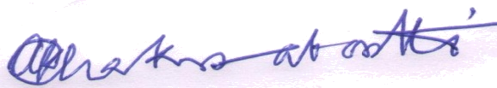
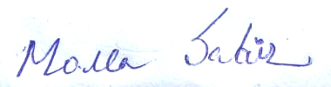

[Signature of expert member] [Signature of authorized representative of Firm]
Date: 22.08.2024
Full name of authorized representative:
Bharat Gaurav Shri Amal Krishna Chakrabortti

Shri Amal Krishna Chakrabortti

Full name of expert: Shri Ramananda Basak

